ITA0601 – MACHINE LEARNING
LAB EXPERIMENTS
Exp-4: Artificial Neural Network using Backpropagation Algorithm
Aim:
To build an Artificial Neural Network (ANN) by implementing the Backpropagation Algorithm and test it using an appropriate dataset.
Procedure:
- Import the required libraries (pandas, sklearn, MLPClassifier).
- Load a suitable dataset (Breast Cancer Dataset).
- Split the dataset into training and testing sets.
- Standardize the input features.
- Create an Artificial Neural Network using MLPClassifier.
- Train the network using the Backpropagation Algorithm.
- Predict the output for the test dataset.
- Calculate the model accuracy.
- Display the confusion matrix and classification report.
Python Code:
import pandas as pd
from sklearn.datasets import load_breast_cancer
from sklearn.model_selection import train_test_split
from sklearn.preprocessing import StandardScaler
from sklearn.neural_network import MLPClassifier
from sklearn.metrics import accuracy_score, confusion_matrix, classification_report
data = load_breast_cancer()
X = data.data
Y = data.target
X_train, X_test, Y_train, Y_test = train_test_split(
X, Y, test_size=0.2, random_state=42
)
scaler = StandardScaler()
X_train = scaler.fit_transform(X_train)
X_test = scaler.transform(X_test)
ann = MLPClassifier(
hidden_layer_sizes=(10,),
max_iter=1000,
learning_rate_init=0.01,
random_state=42
)
ann.fit(X_train, Y_train)
Y_pred = ann.predict(X_test)
print("Accuracy:", accuracy_score(Y_test, Y_pred)
print("\nConfusion Matrix:")
print(confusion_matrix(Y_test, Y_pred))
print("\nClassification Report:")
print(classification_report(Y_test, Y_pred))
Output:
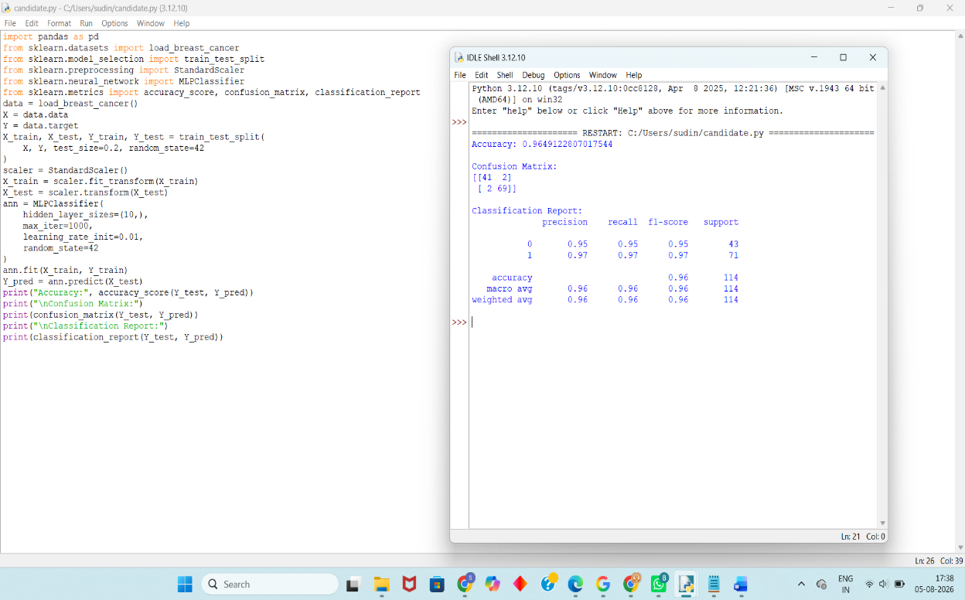
Result:
The Artificial Neural Network (ANN) was successfully implemented using the Backpropagation Algorithm. The model was trained and tested on the Breast Cancer Dataset and achieved high classification accuracy. The confusion matrix and classification report confirmed the effectiveness of the trained neural network.

